**Jonathan Weaver**

**Triangle Pattern of Numbers Test Cases**

| **Input** | **Expected Output** | **Actual** **Output** | **Pass?** |
| --- | --- | --- | --- |
| Enter the number of rows you want: 5 | 1  1 2  1 2 3  1 2 3 4  1 2 3 4 5 | 1  1 2  1 2 3  1 2 3 4  1 2 3 4 5 | YES |
| Enter the number of rows you want: 10 | 1  1 2  1 2 3  1 2 3 4  1 2 3 4 5  1 2 3 4 5 6  1 2 3 4 5 6 7  1 2 3 4 5 6 7 8  1 2 3 4 5 6 7 8 9  1 2 3 4 5 6 7 8 9 10 | 1  1 2  1 2 3  1 2 3 4  1 2 3 4 5  1 2 3 4 5 6  1 2 3 4 5 6 7  1 2 3 4 5 6 7 8  1 2 3 4 5 6 7 8 9  1 2 3 4 5 6 7 8 9 10 | YES |
| Enter the number of rows you want: 4 | 1  1 2  1 2 3  1 2 3 4 | 1  1 2  1 2 3  1 2 3 4 | YES |
| Enter the number of rows you want: 2 | 1  1 2 | 1  1 2 | YES |

**Triangle Patter Screen Capture**

**Test Case 1:**

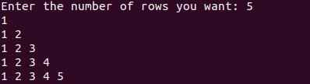

**Test Case 2**

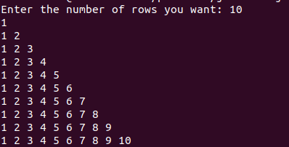

**Test Case 3**

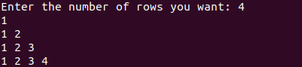

**Test Case 4**



**Rectangle Pattern of Numbers Test Cases**

| **Input** | **Expected Output** | **Actual** **Output** | **Pass?** |
| --- | --- | --- | --- |
| Enter the value of n: 2 | 222  212  222 | 222  212  222 | YES |
| Enter the value of n: 4 | 4444444  4333334  4322234  4321234  4322234  4333334  4444444 | 4444444  4333334  4322234  4321234  4322234  4333334  4444444 | YES |
| Enter the value of n: 6 | 66666666666  65555555556  65444444456  65433333456  65432223456  65432123456  65432223456  65433333456  65444444456  65555555556  66666666666 | 66666666666  65555555556  65444444456  65433333456  65432223456  65432123456  65432223456  65433333456  65444444456  65555555556  66666666666 | YES |
| Enter the value of n: 8 | 888888888888888  877777777777778  876666666666678  876555555555678  876544444445678  876543333345678  876543222345678  876543212345678  876543222345678  876543333345678  876544444445678  876555555555678  876666666666678  877777777777778  888888888888888 | 888888888888888  877777777777778  876666666666678  876555555555678  876544444445678  876543333345678  876543222345678  876543212345678  876543222345678  876543333345678  876544444445678  876555555555678  876666666666678  877777777777778  888888888888888 | YES |

**Rectangle Pattern Screen Capture**

**Test Case 1**

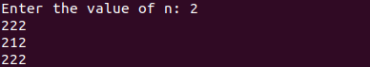

**Test Case 2**

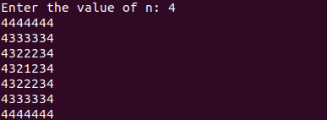

**Test Case 3**

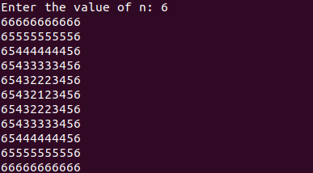

**Test Case 4**

